Jason Family Barber Shop Business Network

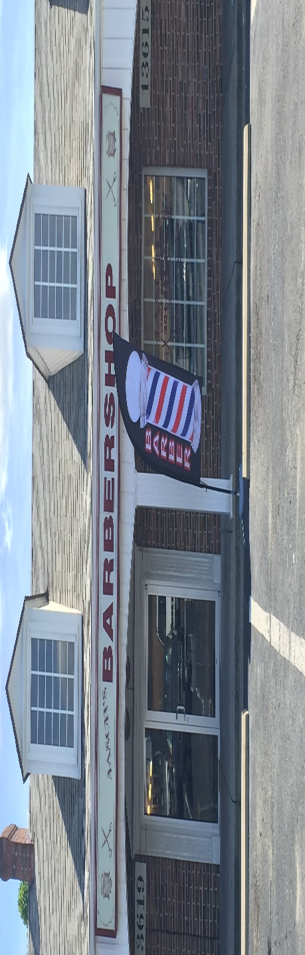
Jason’s Family Barbershop established in 2003 is a Family Friendly Barber Shop located at West Bowie Village at 13619 Old Annapolis Road in Bowie, Maryland. We serve 100+ customers each week ranging in ages of 20-65 who work in diverse occupations. Our customers are interested in business services in all areas. We want to serve as the business connector of our customer to your business. We are inviting you to become a Charter member of our Business Network.
Features of JFB Business Network:
- Monthly newsletter with a business directory
- Quarterly Business Networking
- Opportunity to do affiliate marketing on www.jasonsfamilybarber.com
- Opportunity to participate in E-mail blasts to our database of 300+
Benefits to your Business:
- Your business will maximize your corporate image
- Your business will operate in a network that increases affiliate marketing opportunities
- Opportunity to Increase your revenue with new customers

Jason Family Barber Shop Business Network Membership
12 months – $99.00 6 months - $69.00

Company Name______________________________________________________________
Contact Name_______________________________________________________________
Address____________________________________________________________________
Phone (cell) ______________________________Email_________________________________
Website_________________________________Date______________________________

Jason Pharr 13619 Old Annapolis Road Bowie, MD 20720 (301)860-1914 -shop (240) 882-5390-cell

